**Ex. No : 3 A**

**Date : 13.02.2025**

**Develop application to demonstrate applications of JQUERY and AJAX**

**AIM:**

To Develop application to demonstrate applications of JQUERY and AJAX

**PROCEDURE:**

|  |  |  |
| --- | --- | --- |
| **S.NO** | **Jquery Functions** | **DESCRIPTION** |
| **1** | **$(document).ready()** | **Ensures the DOM is fully loaded before running jQuery.** |
| **2** | **Click()** | **Listens for button clicks (e.g., posting a question/answer).** |
| **3** | **Val()** | **Retrieves or sets input values.** |
| **4** | **Append()** | **Dynamically adds HTML elements (questions/answers).** |
| **5** | **Closest()** | **Finds the closest parent element for targeted removal.** |
| **6.** | **fadeOut()** | **Gradually hides elements (used for deleting questions).** |
| **7** | **slideToggle()** | **Expands/collapses answers smoothly.** |

**SOURCE CODE :**

<!DOCTYPE html>

<html lang="en">

<head>

<meta charset="UTF-8">

<meta name="viewport" content="width=device-width, initial-scale=1.0">

<title>Mini Stack Overflow</title>

<script src="https://code.jquery.com/jquery-3.6.0.min.js"></script>

<style>

body { font-family: Arial, sans-serif; margin: 20px; }

.question-box { border: 1px solid #ccc; padding: 10px; margin: 10px 0; border-radius: 5px; }

.answers { display: none; margin-top: 10px; padding-left: 10px; border-left: 2px solid #007bff; }

.delete-btn { color: red; cursor: pointer; margin-left: 10px; }

</style>

</head>

<body>

<h2>Stack Overflow Mini Forum</h2>

<input type="text" id="questionInput" placeholder="Ask a question..." />

<button id="addQuestion">Post Question</button>

<div id="forumContainer"></div>

<script>

$(document).ready(function () {

$("#addQuestion").click(function () {

let questionText = $("#questionInput").val().trim();

if (questionText !== "") {

let questionHtml = `

<div class="question-box">

<p><strong>${questionText}</strong>

<span class="delete-btn">🗑 Delete</span>

</p>

<button class="toggleAnswers">Show/Hide Answers</button>

<div class="answers">

<input type="text" class="answerInput" placeholder="Write an answer..." />

<button class="addAnswer">Post Answer</button>

<ul class="answerList"></ul>

</div>

</div>`;

$("#forumContainer").append(questionHtml);

$("#questionInput").val(""); // Clear input

}

});

$(document).on("click", ".delete-btn", function () {

$(this).closest(".question-box").fadeOut(300, function () { $(this).remove(); });

});

$(document).on("click", ".toggleAnswers", function () {

$(this).next(".answers").slideToggle();

});

$(document).on("click", ".addAnswer", function () {

let answerText = $(this).siblings(".answerInput").val().trim();

if (answerText !== "") {

$(this).siblings(".answerList").append(`<li>${answerText}</li>`);

$(this).siblings(".answerInput").val(""); // Clear input

}

});

});

</script>

</body>

</html>

**OUTPUT 1 :**

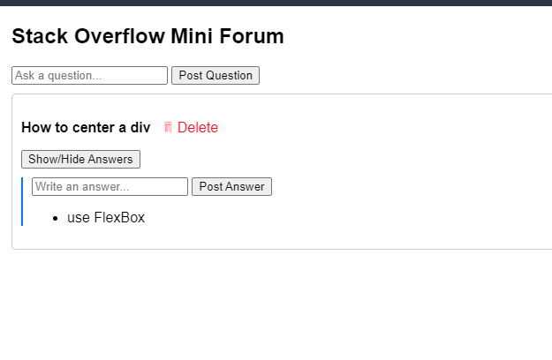

**RESULT :**

The program has been successfully executed and the output is verified.